# Structure of the CLIMB Client for DCC XML file generation

The Python application can be found at <https://github.com/TheJacksonLaboratory/DccXmlGenerator>

The KOMP Production team uses CLIMB to manage the KOMP mouse colonies and report Embryo Lethal and Line-based procedures to the DCC. This app works on specimen and line based procedures. The adult phenotypers do not use CLIMB.

The application is made up of four modules:

* **Climb.py** Calls to the CLIMB API
* **query_database.py** Contains the SQL to update the KOMP schema in the MySQL database found at rslims.jax.org.
* **validate_procedure.py** Contains the validation functions for the JSON objects returned on the CLIMB interface.
* **dcc_xml.py** The main routine. Queries CLIMB validates the results and produces the XML files.

This app uses the API wrapper around the CLIMB API found at <http://bhclimb01wd.jax.org:8000/docs>.

This wrapper was written to avoid the problem of over-fetching from CLIMB and doing large scale filtering on the client side. The wrapper uses FastAPI to do this. The basic, required functions work but we ran out of resources to expand the endpoints as much as we hoped we could.

To view the endpoints go to <http://bhclimb01wd.jax.org:8000/docs#/> and explore /api/animalInfo, /api/taskAnimalInfo, and /api/taskAnimalInfoByLine.

The user can also use the standard CLIMB API within this module.

The application takes a filter defined in JSON format and returns the objects based on the filters.

Currently the filter filename is hard-coded as filters.json. **This should be improved upon.** Also, the filters have not been fully debugged. In fact there are some known bugs that may never be fixed.

For procedures to be included in the XML files they must meet the following criteria.

* Task status must be ‘Completed’ or ‘Cancelled’ to be picked up
* ‘Collected Date’ and ‘Collected By’ must be filled in
* ‘Reviewed Date’ and ‘Reviewed By’ must be filled in
* Required inputs must be set if they exist
* Specimens must have a generation, genotype, sex and
* A line must be of the following type:
  + KOMP Active
  + KOMP Complete
  + Embryo Lethal Complete
  + Embryo Lethal Active
* Lines must have the ‘reference’ field filled in with the MGI access ID

When a procedure is submitted that fact is recorded in the MySQL database schema KOMP, table submittedProcedures. For example:

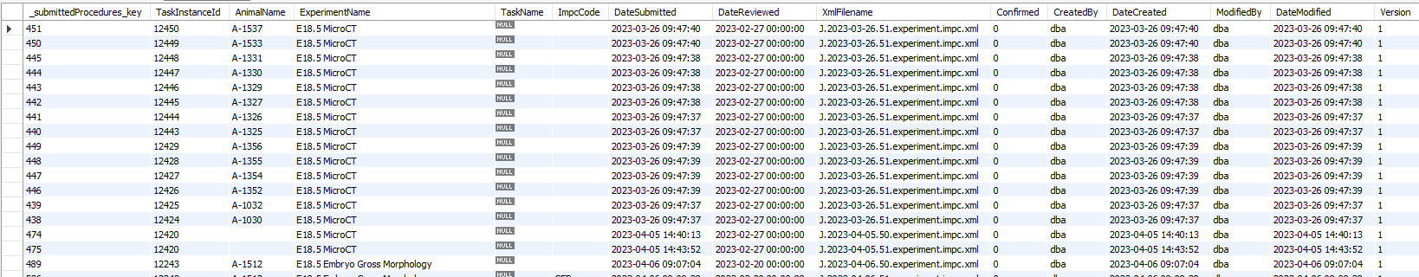

The application checks for a newer DateReviewed for each procedure. If the DateReviewed is newer the procedure is included in the XML file. Otherwise, it is assumed to have been uploaded and, consequently, ignored.